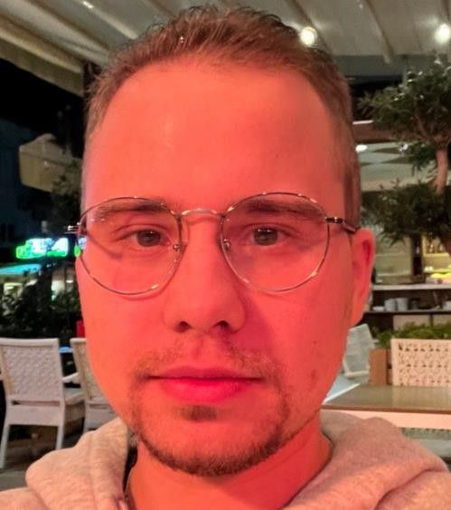 | Male, 27 years, born on 20 April 1996  +382-68-710-479  kozyrevma96@mail.ru  Residence permit in: Montenegro.  Citizenship: Russia.  Currently in Montenegro. Ready to relocation, ready for business trips

MIKHAIL KOZYREV – SOFTWARE ENGINEER

SUMMARY
Java Developer with 3+ years of experience in commercial software development (SCRUM). Punctual and self-motivated. Passionate about life science projects.
Technologies I worked with (hands on experience):
- Java stack:
  - Java 8-17
  - Spring Framework (Boot, Data, MVC)
  - Mockito, JUnit4+, Docker TestContainers
  - Maven, Gradle
- Databases:
  - PostgreSQL, MS SQL, Blazegraph
- Non Java stack:
  - Cloud: AWS S3, Batch, ECR
  - Containers and Orchestration: Docker, Singularity, Kubernetes(minikube mostly)
  - Pipeline build technologies: Nextflow 23+(DSL2)
  - Bio-informatics: CellProfiller, BLAST
  - OS: Windows10/Ubuntu 22.04/20.04/18.04
- Extra:
- Medical, life science expertise
- Experience of interviewing java developers

WORK EXPERIENCE

October-2023 – Now – Software Developer, Kupsilla Inc
Customer Description: Software & Hi-Tech.
Project Description: creation of the Gradle Plugin for various projects generation.

Responsibilities: created custom templates, using FreeMarker. Make changes in OpenApi configurations to generate Swagger UI. Add support for integration testing with Docker TestContainers.
Team Size: 2 developers, architect, project manager, 3 QA, 2 BA.
Tools and Technologies: Java 17, Gradle, PostgreSQL, Spring Boot 3+, Spring Data, Apache Freemarker, OpenApi Mustache, Swagger, Flyway, Docker.

October-2023 – January-2024 – Software Developer (spare time), Kupsilla Inc
Customer Description: Life Sciences & Healthcare
Project Description: proof of concept for the customer, which runs various bio-informatics pipelines

Responsibilities: rewrote the pipeline for newer version of Nextflow 23+ (using DSL2), created Docker image of the pipeline, deployed pipeline in AWS Batch. Transfer Docker image to Singularity.
Team Size: standalone
Tools and Technologies: Nextflow, CellProfiller, Docker, Singularity, AWS S3, Batch, ECR.

March-2023 – October-2023 – Software Developer, Kupsilla Inc
Customer Description: Life Sciences & Healthcare
Project Description: Support activities on the platform for chemical laboratory, an integrated suite of digital solutions that deliver the full chain of functionality required by chemical laboratory.

Responsibilities: features implementation, writing Unit and integration tests, bug fixing, code review. Participation in onboarding of new team members. Continuous interactions with testers and business analysts.
Team Size: 4 devs, 3 QA, architect, 2 BA, Project manager, Delivery manager.
Tools and Technologies: Java 17, Gradle, PostgreSQL, Spring Boot 3+, Data, MVC, RDKit, Flyway, Swagger, Docker.

January-2023 - March-2023 - Software Developer (spare time), EPAM Systems
Customer Description: Software & Hi-Tech.
Project Description: telegram-bot for convenient accommodation search.
Team Size: 2 backed developers, project manager.

Responsibilities: add integration with AWS S3, feature development, bug fixing.
Tools and Technologies: Java 17, Gradle, MongoDB, Spring Boot 3+,Data, JUnit4+, Mockito, Flyway, Docker.

May-2022 – March-2023 - Software Developer, EPAM Systems
Customer Description: Software & Hi-Tech.
Project Description: Feature Development & Support for Workforce Ready application.
Team Size: 4 devs, 3 QA, Scrum muster, Project manager.

Responsibilities: participation in SCRUM procedures. Creation of new API for business entities. Participation in onbording of new team members. Code review. Bug fixing. Continious interactions with developers and testers from other teams.
Tools and Technologies: Java 17 + custom frameworks, MS SQL, Gradle, Flyway, Docker.

Feb-2021 - Mar-2022 - Software engineer, EPAM Systems
Customer Description: Life Sciences & Healthcare.
Project Description: Support activities on the platform for genomic laboratory, an integrated suite of digital solutions that deliver the full chain of functionality required by clinical genomics organizations
Team Size: Backend: 9, Frontend 1, Project manager, DevOps: 2,QA: 2.

Responsibilities: implementation of new functionality for genomics analysis. Continuous interaction with sub teams of the project (DevOps, frontend, business analysts). Bug fixing. Participation in Scrum procedures. Took part in newcomers on-boarding. Code review.
Tools and Technologies: Java 11, PostgreSQL, Blazegraph, Cassandra, AWS S3, Maven, Flyway, JUnit, Mockito, Spring Boot, Spring MVC, Spring Spring Data JPA, jOOQ. Docker, K8S(minikube), Jenkins. Python 3, Bash.

Oct-2020 - Feb-2021 - Junior Software Engineer, EPAM Systems.
Customer Description: Software & Hi-Tech.
Project Description: the idea of the project is to identify and monitor the position of the customer inside the building.
Team Size: 7 backend, 2 frontend, 1 DevOps, Project Manager.
Responsibilities: code review, code refactoring, features implementation, documentation writing, participation in Scrum procedures.
Tools and Technologies: Java 8, MongoDB, Gradle, Spring Boot 2+, Spring Security, JUnit, Mockito, Kafka.

